Assignmet 12.3
Create a list of tuples, where the 1st element of the tuple is an int and the second
element is a string.
Example - ((1, ‘alpha’), (2, ‘beta’), (3, ‘gamma’), (4, ‘zeta’), (5, ‘omega’))
- for the above list, print the numbers where the corresponding string length is 4 fot list of tuple
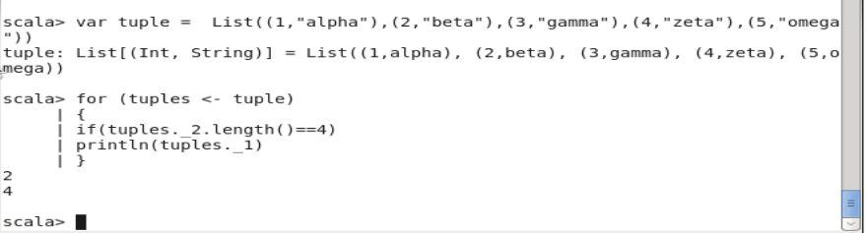

- find the average of all numbers, where the corresponding string contains alphabet ‘m’
or alphabet ‘z’
